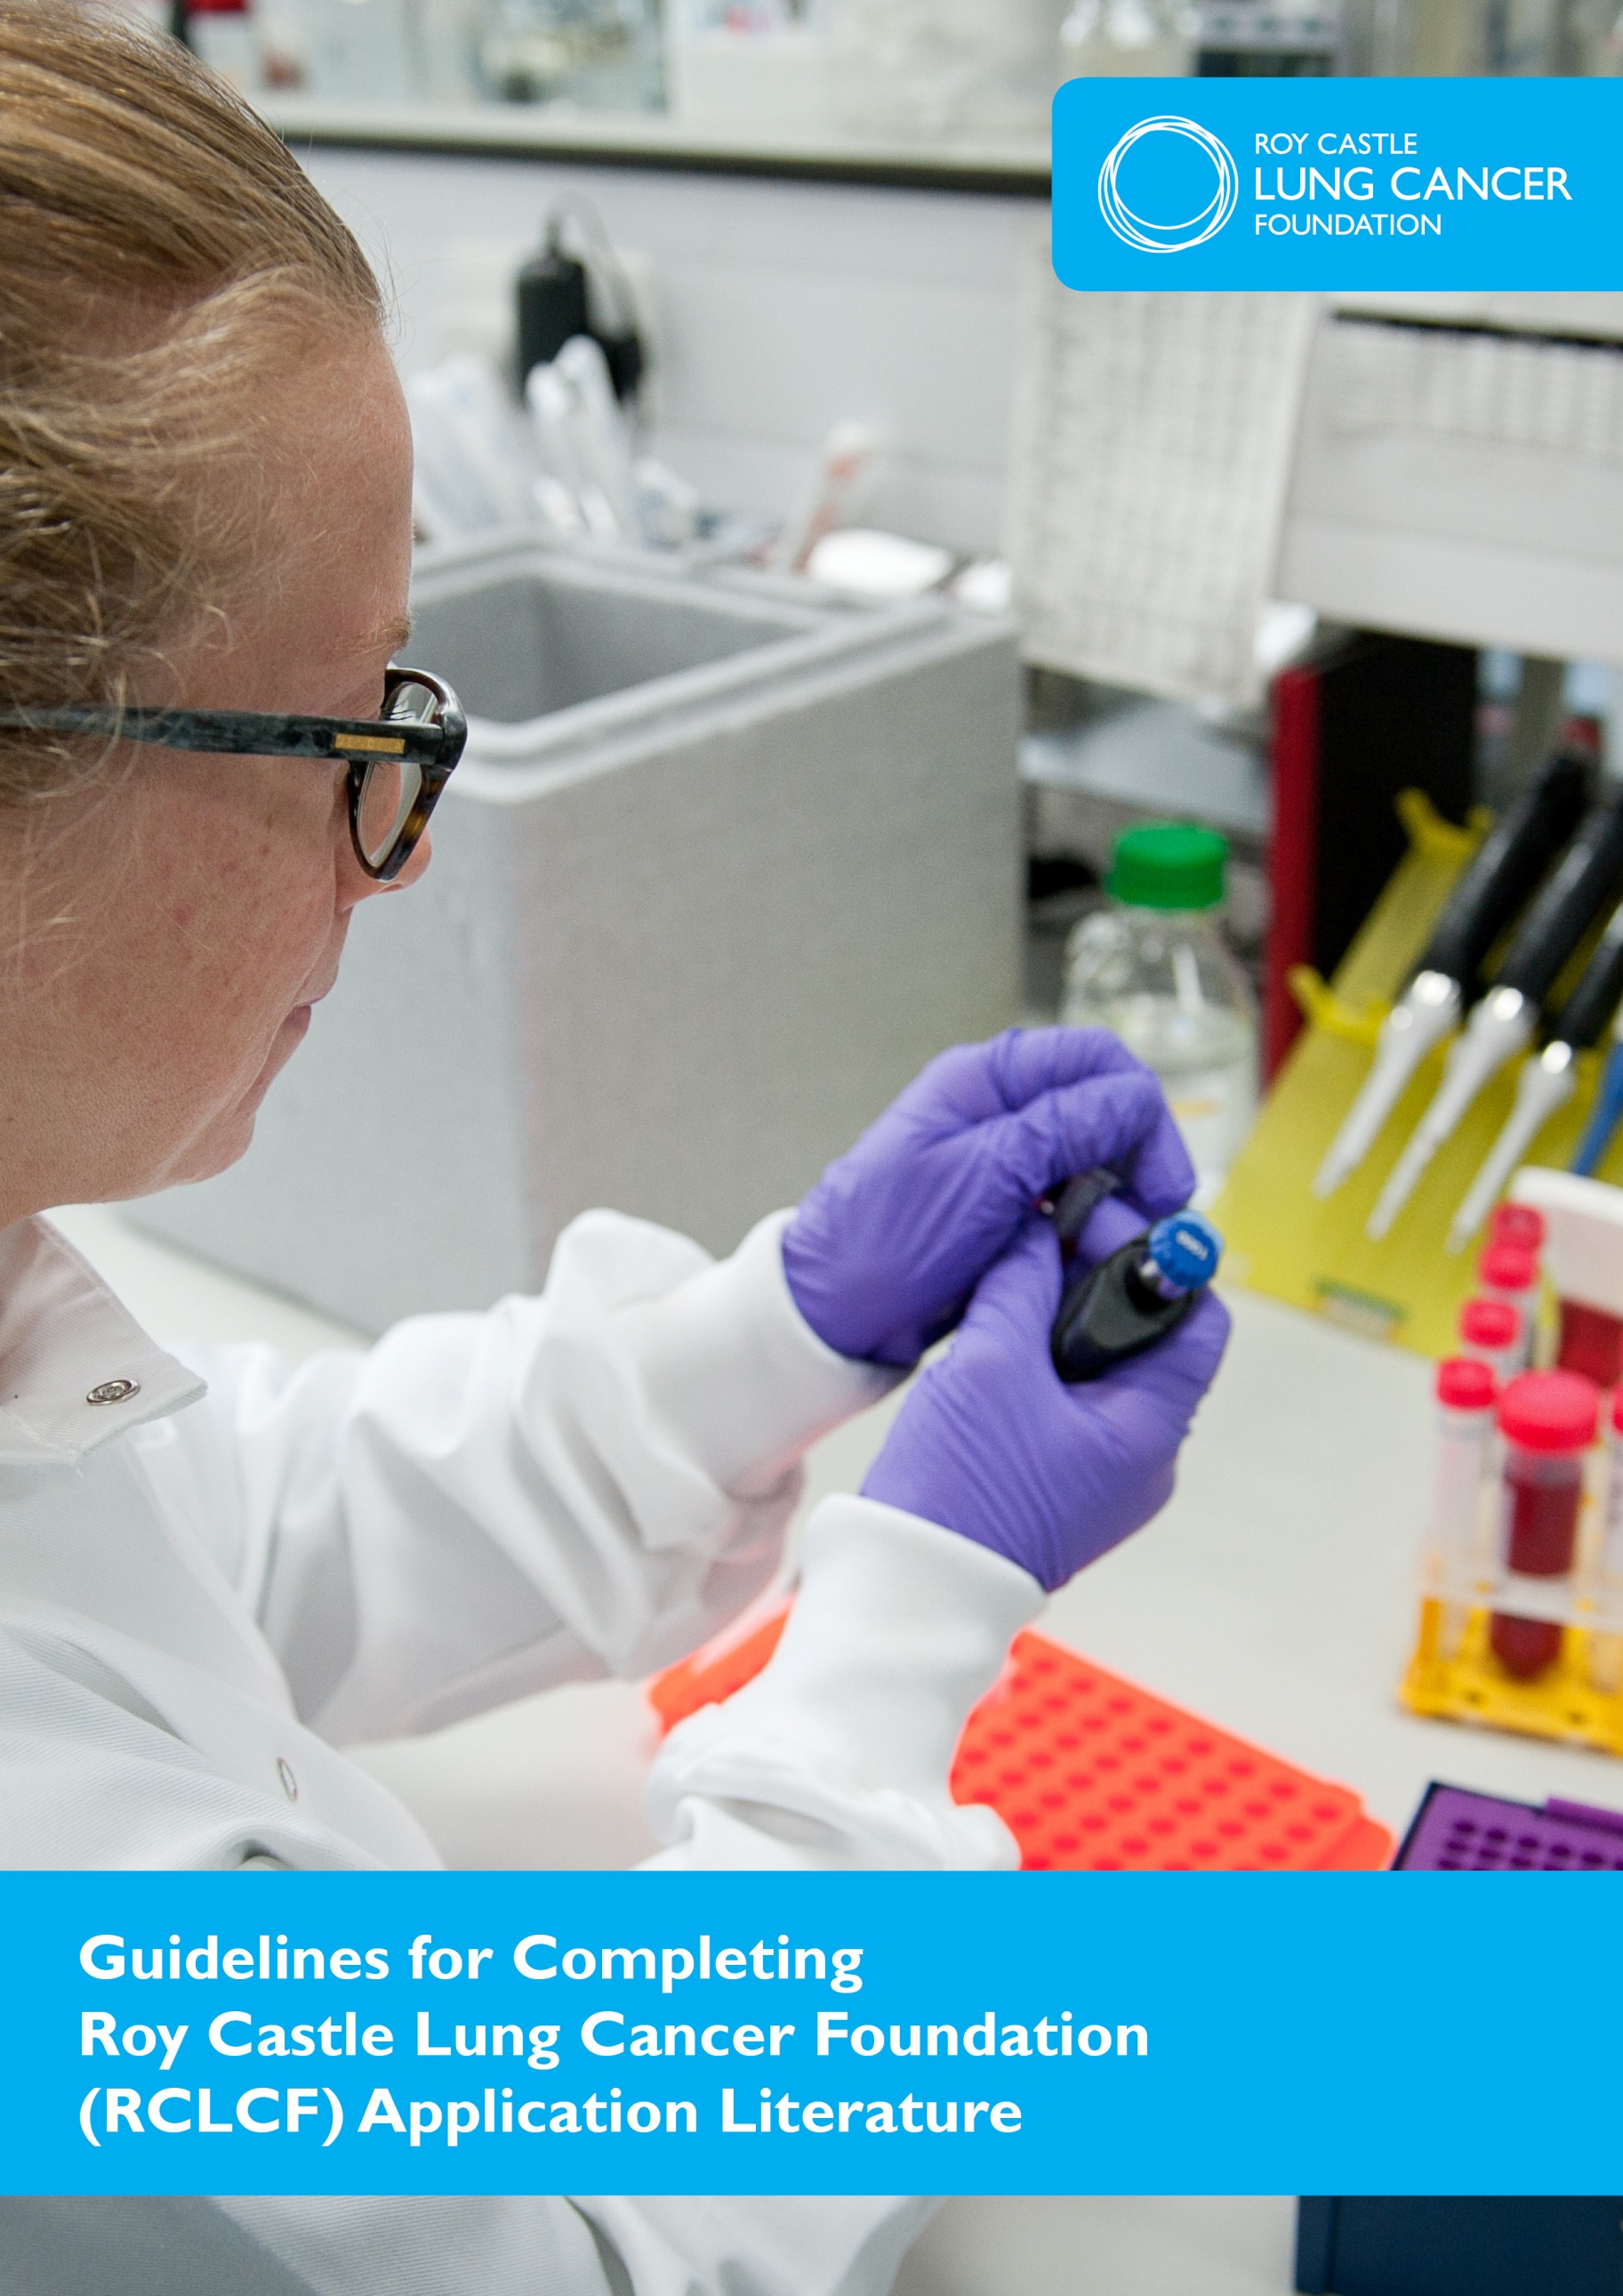

Thank you for your interest in RCLCF research funding. The current open grants round is for projects with start dates 1 January 2020, or shortly thereafter.

Please use the following guidelines, in conjunction with the ‘RCLCF grant funding information’ document when you are completing your application.

These guidelines do not cover all the headings that you need to complete on the application form; they address the ones you may have questions about.

If you have any queries, please email grants@roycastle.org

Please type throughout in Gill Sans MT typeface (font size twelve).

All applicants must complete:

Form A: Lay Summary and Scientific Abstract

and either

Form B PROJECT: Research proposal (up to £75,000 per annum for 1 or 2 years)

or

Form B PILOT: Research proposal (up to £25,000 for 1 year)

Completing form A: Lay Summary and Scientific Abstract

This section will be used to assess applications for continuation to second stage (ie full review by Grants Committee and external review).

In order to promote a better understanding of the research RCLCF funds the information on this page will be used to describe this grant to relevant stakeholders, including our trustees and supporters. The information may also be used for fundraising purposes to ensure we can fund your research should your application be recommended for funding.

Should the grant be awarded the information may be used in lay publications and the audience may include existing and potential donors to the charity. It is essential that all parities understand why and how their money is being spent.

Project title:
This should be a maximum of 12 words and written in sentence case.

Project award: Please indicate the type of award: project or pilot.

Grant holder and researcher: This should be the name of the main applicant and the appointed researcher (if known at the time of application).

Institution: Name of the host institution where the grant will be held.

Lay Summary

This section should be completed in LAYMANS terms and free from scientific terminology.

Brief background information to be completed in no more than 100 words

The following questions should be completed in no more than 1,000 words

What is the problem to be addressed?

What is the research question?

How are you going to do this?

What will this find? Anticipated outcome

Where could this potentially lead? Indicate what the relevance of the outcome of the research is to patients with lung cancer or those who are at risk.
Scientific Abstract

All questions should be completed and contain no more than 1,000 words in total.

What is the research question?

Methods? Outline the methodological approach to be taken. Include details of statistical design, source of statistical advice (if relevant) and how lay persons/patients were involved in creating this proposal.

Proposed timeline?

Potential impact? Indicate what the relevance of the outcome of the research is to patients with lung cancer or those who are at risk.

Completing form B:

Section 1 Application Details

Category and type of application
Please refer to RCLCF’s grant funding information document for descriptions of the different types of award RCLCF offers and select the appropriate option (project grant or pilot grant).

Applicant
Enter one name here, the principal investigator. This person will be the main contact, and grant holder, whose name will be in all correspondence.

Institution
Name of the host institution where the grant will be held.

Address
This should be the full postal address of where the grant will be held and the address of the main contact. If the project is based in more than one institution, one must be chosen as the host institution.

Title of project
This should be a maximum of 12 words and written in sentence case not in capitals and should accurately reflect the content of the research proposal

Proposed start date
Projects must start within nine months of the earliest start date stipulated by RCLCF (currently 1 January). Award letters will be received by the end of November in the year of application.

Total amount of funding applied for
Applications for funding should be based on actual expenditure and all figures should be entered in GBP (£ Sterling). Invoices will be paid in GBP (£ Sterling) and converted to the currency of request by the bank at their exchange rate on the day the transfer or draft is actioned. RCLCF is not responsible for losses incurred through fluctuations in exchange rates.

Co-applicant(s)
Up to six co-applicants are permitted and should be listed here.

Other Support
If this research supported by any other outside bodies, indicate the organisations, degree and time scale of support.

Section 2 Research Category

Please select from the research categories outlined the one category that your research proposal falls within.

Categorising your application will assist RCLCF to monitor the types of applications received and funded. This information is for monitoring purposes only and the information you provide will have no bearing on the referees selected to review your proposal, nor on the decision of whether to award the grant.

Section 3 Research Proposal

There are 2 different version of form B (depending on whether you are applying for a PILOT or a PROJECT grant), please ensure you complete the correct version of form B.

Please note that failure to use the exact headings specified will result in your application being removed from consideration.

This section should be written in Gill Sans MT font size 12, using single spacing and with the following margins - top and bottom 2.54cm and left and right 2.54cm.

Headings A-K of the proposal (including all tables, diagrams, figures, legends etc and group references) should be:

- a maximum of five pages for project grants
- a maximum of three pages for pilot grants

The reference list for the research proposal should be completed under heading L and be a maximum of two additional pages.

Failure to adhere to this will result in your application being removed from consideration.

A. Main applicant
Name as indicated in section 1 of form A.

C. Aims and purpose
Give details of the objectives of the research and significance of the results that may be obtained, and their relevance to lung cancer

E. Plan of investigation and methodology
Include details of experimental methods, techniques and analyses to be used to test the proposed hypotheses. This should include quantitative information on the material to be used and its source(s). Where possible preliminary data supporting the proposed research should be included.
Include details of statistical design and source of statistical advice (if relevant).
Also include, where relevant (for example if formal statistical inference will be performed), details about sample sizes and power calculations should be given including as appropriate:

- The outcome measure on which the power calculations are based
- The size of the difference that the study is powered to detect, and justification of positing that size

For population studies further details should be given including as appropriate:

- The outcome measure on which the power calculations are based
- The likely prevalence of the exposures of interest
- The justification for the choice of the type I error rate
- The justification for the effect size that the study is powered to detect
- Details on how assumptions made about the completeness of follow-up and covariate data have been taken into account

If microarray, sequencing, metabolomic/proteomic techniques or other methods generating high volume data are to be used give details about the bioinformatic support and statistical analysis to be applied to the data. Consider if you need expert input from a statistician or bioinformatician. If this is required a letter of collaboration from a named statistician or bioinformatician must be included with the application. A justification of the number of samples to be used in such studies should be provided.

Indicate, if relevant, how lay persons/patients were involved in creating this proposal.

F. Potential problems envisaged and how these will be addressed
Please indicate any potential problems or challenges you anticipate with your proposed plan of investigation, and how these would be addressed.

G. Timescale of investigation and project milestones
Please include a table outlining research objectives and the month/year in which you propose they will be achieved.

H. Describe how this project integrates into the ongoing work of the main
applicant
RCLCF assumes that the main applicant is the supervisor of the project.
Include an explanation of how the proposed work does not overlap with existing
work, scientifically or financially.

I. Define the expected value of the research to the academic community and lung cancer patients
Please refer to RCLCF’s research strategy’s key principles and objectives. Also indicate fit with RCLCF’s two key areas of project funding: Early Detection of lung cancer and Patient Experience. This should include expectations for both long and short term objectives for the results of the project.

J. List of collaborators, but not co-applicants
Letters confirming collaboration from all listed collaborators must be included with the application; this is acceptable in email format.

K. Publications from your group relevant to this application
If your papers have been submitted and /or not yet published, please send these as a list along with the abstracts; if your papers have been published, please send the citations only, copies of unpublished manuscripts may not be appended. Abstracts can be appended and are not included in the five page limit for research proposals.

L. References
The reference list must not exceed two pages.

M. ‘Re-funding’ of a current grant or ‘follow on’ from RCLCF pilot grant
If you are applying for continuation of a current RCLCF grant or a follow on application from a RCLCF pilot grant, please outline the initial aims of your previous project, how you have achieved those aims and how the new project builds on your previous work. This should be a maximum of two pages in addition to the five page research proposal. Any publications and presentations resulting from your previous project should be included in an additional appendix.

N. Final or most recent interim report for any current or completed RCLCF grants held by the applicants
In addition to the research proposal please attach any final year reports submitted to RCLCF for completed RCLCF grants held by the applicant and co-applicants, and the most recent interim report for current completed RCLCF grant.

An application will not be accepted if a final report on any RCLCF funded research grant previously held by the principal applicant is overdue.

O. Please provide the name and contact details of TWO suitable experts to potentially externally review this grant submission

Note: If you wish to include confidential unpublished data in your application which you do not wish to be seen by external reviewers, this should be submitted in a separate document to the application forms. This information will be treated as confidential; it will be held in the office and will only be seen by the RCLCF Grants Committee.

Section 4 Curriculum Vitae

Please include current CVs for the main applicant, all co-applicants and the appointed researcher (if known at the time of application).

Duplicate this page and complete a CV for each applicant and co-applicant.

Please note that a maximum of two pages only will be accepted for each CV.

Personal details

Status
Indicate main applicant / co-applicant / researcher

Name
Enter as Surname, First Name, Title.

Qualifications
Please enter the date, awarding body eg, University, subject and where necessary the class of award.

Current position
Please enter the date you started, institution and position.

Posts held
Please enter the date you started, institution and position. Please list no more than your last five positions.

Current grants held
Include start date, length of grant, funding body, title and amount.

Other RCLCF applications under consideration
If the main applicant or co-applicants has an application under consideration in the same round as this proposal, please detail the grant title and reference number and the name of the grant holder.

Publications
List the five most recent and/or relevant including title and full bibliometric data. Please under-line the name of the investigator.

Section 5 Additional details

Intellectual property body
Please see ‘RCLCF grant funding information’ (section 7.2.5) for our policy on intellectual property. Please provide the name of your host institutions’ IP body.

Commercial significance
Please outline if the results of this research are likely to have commercial potential. Also outline if there has previously been any patent filed or commercial interest expressed in the research related to this application.

Ethical considerations
Please see ‘RCLCF grant funding information’ (section 7.2.9) for our policy on Patient involvement in medical research.

If this project requires Ethical Committee approval, please indicate here and attach the relevant Ethical Approval letter to the application. If ethical approval is pending, or to be sought once funding is confirmed please indicate here, along with the proposed timeline.

Research involving tissue samples and/or cell lines
If human tissue samples are being used give details of where they will be obtained from. Consider if you need expert input from a pathologist. If this is the case a letter of collaboration from a named pathologist is required. Provide power calculations used to determine the appropriate sample size.

If cell lines are being used quantitative information on the material to be used and its source(s) is required. If new cell lines are to be obtained externally give details of where they will be sourced from, and how they will be authenticated on receipt.

Details on what procedures will be undertaken to validate/authenticate the cell lines, to ensure they are free from cross contamination, microbial contamination and phenotypic drift must be given. Plans to validate cell lines at the start of the project and throughout the research must be given.

Section 6(a) Previous RCLCF grants held

Each applicant and co-applicant who has previously held a RCLCF grant must complete this section in full. If this section does not apply please delete the page.

Previous RCLCF grants held

Short update of the main outcome of this grant
This section should be a maximum of five bullet points long

Publications directly resulting from this grant
Only citations of papers published or in press must be included. Please do not attach abstracts or full manuscripts.

Section 6(b) Award specific section to be completed for pilot grant applications

Pilot grant application
To be completed by the applicant and must not exceed one page.

If the pilot study is awarded please consider how this one year grant will lead to development of a full application
Pilot grants will only be awarded if it can be clearly identified that support is for a new direction of research for researchers to test hypotheses for up to a year to provide sufficient data for a full application to RCLCF.

It is therefore expected that a pilot grant will be used to fund a discrete piece of research and will not be supplemented from other sources. The applicant must fully consider how this one year pilot grant will lead to the submission of a full project to RCLCF.

Section 7 Costs

Personnel details
This section is intended to detail the individuals who will directly work on the research proposed. If you are applying for more than one salary, please fill in all the relevant boxes.

Qualification
Please note here the highest qualification achieved by the researcher (or required if the post is currently vacant)

Grade and Scale point
The grade and scale point at which appointment is expected should be noted here. A copy of the grade/scale system used must be submitted with the application.

% time
Please note here what percentage of time the researcher will spend on the project.

Salary
Please append a copy of the current, relevant pay scale system used by the host institute.

Applications should include any salary increases expected to take place during the period of the grant, including annual increments based on the host institution’s salary scale and potential inflationary increases. Salaries should be costed from the proposed start date of the project not the date of the application.

Contact your finance department for advice on potential salary increases.

Employer’s oncosts
These costs are superannuation/graduated pension and NI contributions and should be included in the salary for all staff.

Running Expenses
A detailed breakdown of all minor equipment and materials and consumables is requested.

Any costs that do not fall under the headings should be listed under ‘other expenses’. These should be fully justified and may not include publication, printing, conference travel, or staff recruitment costs or any other disallowed costs listed below.

RCLCF provides grants on the understanding that the host institution meets the overhead and infrastructure costs. Infrastructure costs include items such as lighting, heating, telephones, use of library facilities, general laboratory equipment, general office expenses, core laboratory services (wash up and waste disposal) and maintenance and running costs of laboratory equipment.

RCLCF will not normally pay for central support staff e.g. secretarial support nor photocopying, printing or postage costs etc, (except in cases where the volume of paperwork and mailings are considerable for example epidemiological or psychosocial studies).

RCLCF will only fund directly incurred costs and not the full economic costs of research (fECs) or a proportion of these.

Note: Minor equipment
RCLCF assumes a basic level of equipment provision by the host institution. The items requested here must be required specifically for the research proposed. New requests for equipment will not be considered once the project has started.

RCLCF will not fund a large piece of equipment, unless the project cannot proceed without it being in place. Full justification for the equipment request is required and must be included in the research proposal. Maintenance costs should be included under Other Expenses.

Note: Open access
Applicants can apply for up to £1,500 towards open access OR a Travel Budget, as the applicant sees fit.

Note: Travel costs
RCLCF will cover costs for travel to conferences where RCLCF work is being presented. Please refer to ‘RCLCF grant funding information’ document for details. These travel costs should not be included in the application form, but will be reimbursed upon submission of appropriate invoice with receipt.

Travel related to the research proposal (for example participant expenses to travel to focus group meetings/interviews/assessments or travel between collaborating centres) is permissible if fully justified.

Funding for travel to conferences can be applied for in place of the open access budget, as the applicant sees fit.

Note: allowed and disallowed costs
These allowed and disallowed lists are not exhaustive and RCLCF may contact you to query costs or ask you to remove any costs deemed to constitute the full economic costs of research

Allowed
- Salary for the member(s) of staff carrying out the research
- Laboratory materials and consumables directly attributable to the project
- Microarray or sequencing costs
- Small pieces of equipment (including PCs) if essential for the project
- Computer software licence (if required specifically for the project, for example image analysis)
- Access charges for shared equipment (for example hourly charge to use microscopy or mass spectrometry equipment)
- Pathology service costs
- Statistician advice/consultancy costs
- Costs associated with authentication/validation of cell lines
- Travel related to the research proposal (for example participant expenses to travel to focus group meetings/interviews/assessments)

Disallowed
- Infrastructure costs (such as lighting, heating, telephones, use of library facilities, general laboratory equipment)
- General office expenses (photocopying, postage etc). An exception may be made for secretarial assistance and printing costs for epidemiological/questionnaire based studies
- A proportion of central support staff salaries (e.g. secretarial support)
- A proportion of general technician salaries (for e.g. wash up, waste disposal etc)
- A proportion of PI or CoI salary for supervision time
- Equipment maintenance and running costs
- Staff recruitment costs
- Publication or printing costs
- Purchase of books
- Travel expenses to attend conferences (a separate travel award may be given, if the application is successful so these costs should not be included in the research proposal budget)

Section 8 Justification of Costs

Include justification for costs requested including:

- The level of member of staff requested and increase in salary anticipated during the grant
- Minor equipment required

Section 9 Approval and ratification

Signatures of Head of Department, Finance Office and Research and Development Department

The application must be submitted by/through the Head of Department and also the Officer who will be responsible for administering any grant that may be awarded for example finance officer, bursar or registrar.

The contact details provided for the finance officer should be the relevant person to contact in the event of budgetary or invoicing queries should the grant be awarded.

We also require the contact details of the institute’s research and development department. They should complete the relevant declarations along with the main applicant, all co-applicants and, where relevant, the second supervisor for a PhD studentship application.

Signatures of applicants and co-applicants

The application must also be signed by the main applicant and all co-applicants. Please fill out and attach a separate sheet for each person.

Section 10 Final Checklist

Please tick and sign this section to confirm that you have checked your application and ensured that all sections have been completed, all additional documentation is attached and that all necessary signatures are provided.

Any late additional information will not be attached to any application by RCLCF and may result in your application being withdrawn from consideration.
Submission of an application indicates full acceptance of the terms and conditions of award as detailed in section 7 of the ‘grant funding information’ document.

Submitting your application form

Email a copy of the application forms to grants@roycastle.org

Forms A and B should be sent in MS Word and pdf format. If documents exceed 10MB please send via Dropbox
Supporting documents must also be sent by email in an appropriate format, for example pdf, word or excel.

When emailing your application, the subject of your email should read:
Month and year of award meeting project/pilot and the applicant’s name, for example; 2019MarProjectJones.

All application forms and supporting documents should be saved with a file name in the same format, for example; 2019MarProjectJones form A.

In addition to the emailed copies you must also submit a signed original.

The hard copy should be sent to the RCLCF office:

Jackie Tebbs
Head of Clinical and Research Projects
Roy Castle Lung Cancer Foundation
Cotton Exchange Building
Old Hall Street
Liverpool L3 9LQ

Please note that only applications submitted using the most up to date RCLCF application literature will be considered for review.

